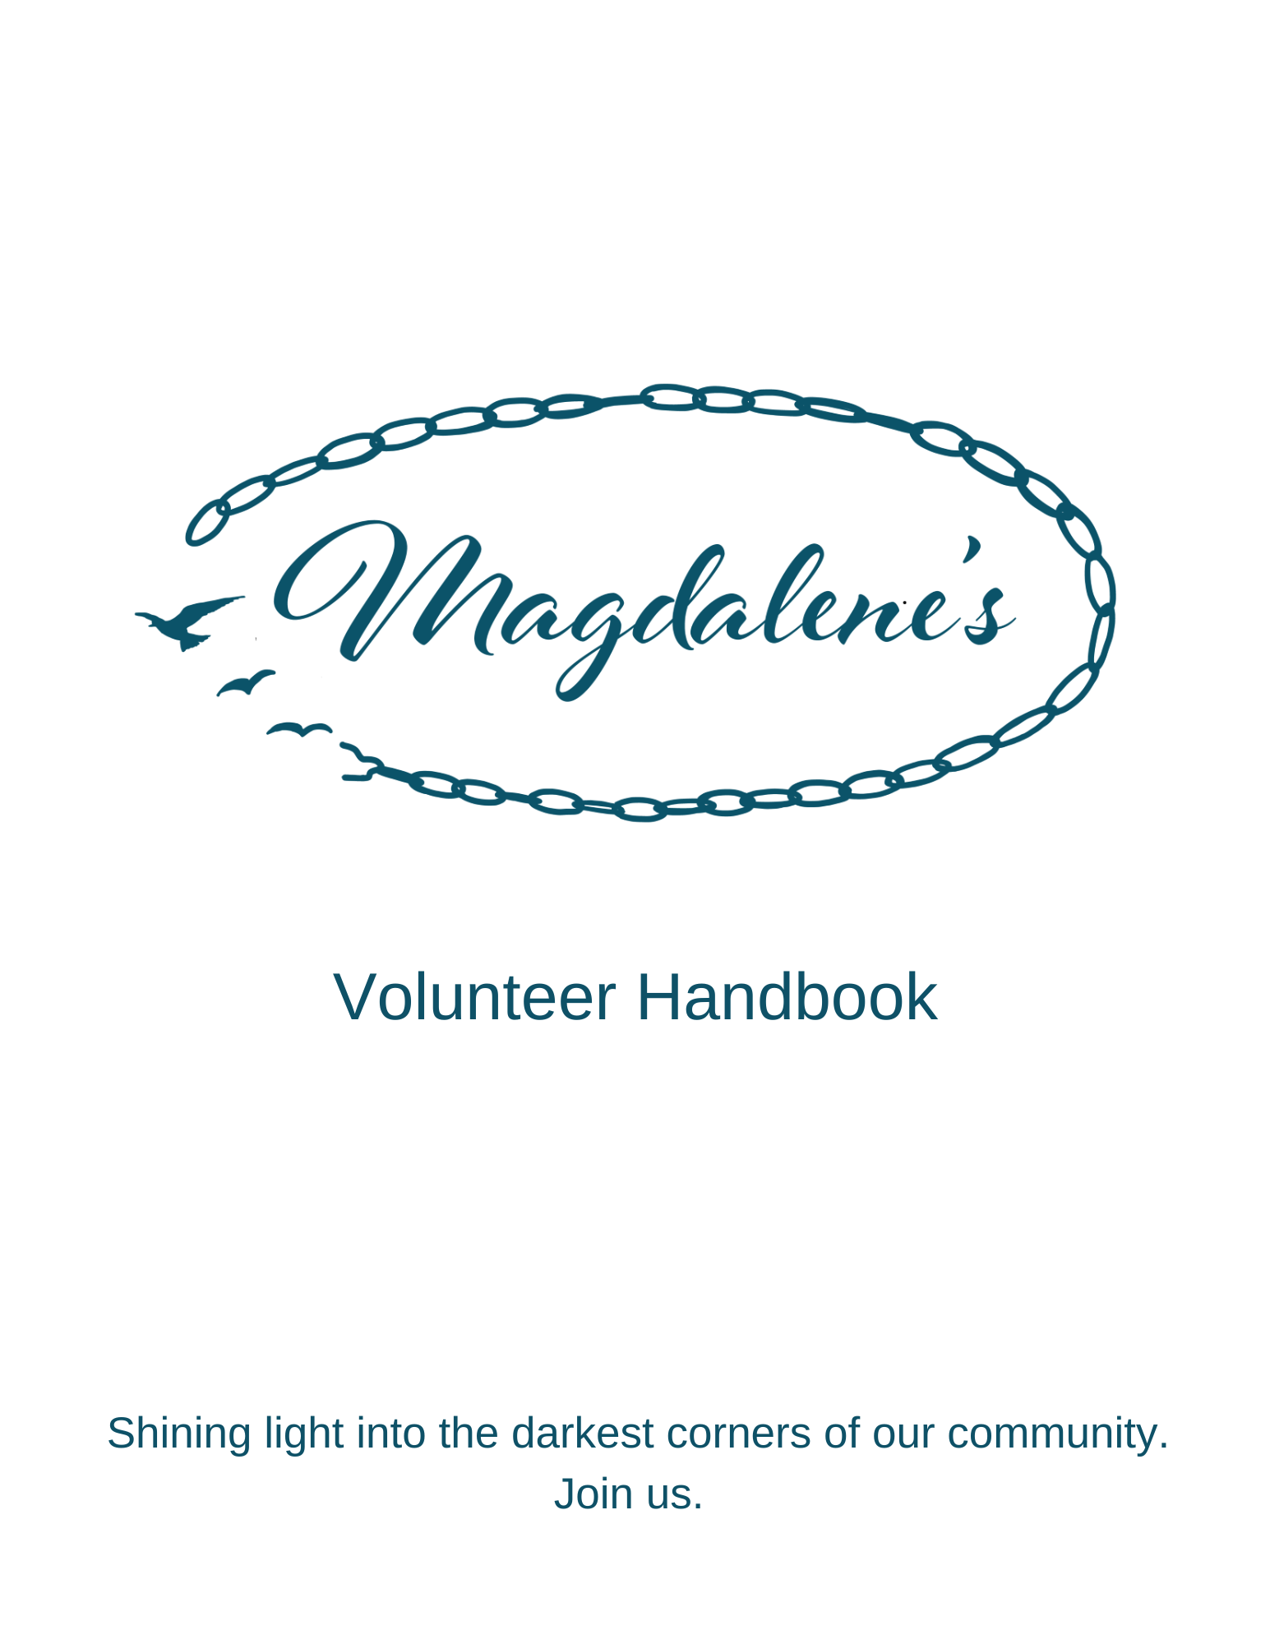

Introduction

Address and Contact Information
Magdalene, Inc.
Phone: 850.565.4035
Email: info@magdalenes.org

General Information
Magdalene's fights trafficking and serves survivors and our community in these key ways:
1. Education & Awareness - speaking to businesses, churches, and civic organizations, as well as hosting events to bring awareness to the atrocity of trafficking
2. Referrals - connecting survivors and community members to the help they need regarding trafficking
3. Survivor support - helping survivors with income opportunities

Scriptural Foundation
He has sent me [Jesus] to bind up the brokenhearted, to proclaim freedom for the captives and release from darkness for the prisoners … to comfort all who mourn … to bestow on them a crown of beauty instead of ashes, the oil of joy instead of mourning, and a garment of praise instead of a spirit of despair. … They will rebuild the ancient ruins and restore the places long devastated….(Isaiah 61:1-4) NIV Excerpt

Core Values
These core values were carefully developed with our entire community in mind, including the women we serve, our volunteers, our customers, our donors, our employees, our friends and our local community.

Love. We are driven by our collective faith to share what we have so generously received, God’s transforming love. Only out of that love can we love each other and love others well and serve with a generous and life-giving spirit. Only God’s love can break down evil and bring restoration from brokenness.

Truth. We value God’s truth that every woman is created in the image of our God, having immeasurable worth, loved from eternity, pursued by God’s Spirit from birth and deserving to be treated with the greatest of dignity. Her God-ordained role is one of royalty; she was born to be the daughter of a King. Our role is to cooperate with God as He reveals her glory.

Spiritual Sanctuary. Our desire is to offer spiritual sanctuary to all women wherever they are on their journey toward healing and restoration. We define spiritual sanctuary as a space that offers beauty, understanding, empathy and honor for one another and a place to experience God’s compassion, grace, forgiveness, redemption, hope and joy. This sanctuary provides a sense of coming home, a space where souls can rest, and each new story can begin.

Safety. We are committed to the physical, mental, emotional, and spiritual safety of every woman involved with Magdalene’s.

Respect. We value and respect all people entrusted to us by God. We are committed to encouraging one another and calling out the best in each other. We commit to listening to each other, learning from each other and growing together. We understand that respect includes authenticity, honesty, trustworthiness, integrity and accountability, and we are committed to respecting our community in that way.

Service. We believe we are called to humbly serve, counting others as more significant than ourselves. We serve because Jesus served without hesitation, reservation, or condition and taught us to do likewise.

Website
www.Magdalenes.org.

Programs

Magdalene's Gifts
Magdalene's Gifts is now in the formation stage as our physical location closes March 28, 2024. Current plans include offering short-term shopping experiences (or “pop up” retail”) at area markets, festivals and other special events. Products will at least include handcrafted items by survivors. Duration, hours and location will vary, depending on the opportunities available in the community. More important than the shopping experience is that Magdalene’s will be able to expand its reach in the two-county area, carrying its message about the reality of trafficking in our community, how to spot it and how to report it.
Education and Awareness
Magdalene’s hosts trainings to educate our community about the reality of sex trafficking in our area, how to detect trafficking and how to report it. Volunteers are needed to man registration tables, serve as greeters, help with technical requirements, etc.
Survivor Support
Magdalene’s assists survivors by engaging them in opportunities to earn compensation for vocational and professional services. We also work with area providers in providing job readiness training.

Volunteers

Getting Started
Thank you for choosing to serve with Magdalene’s! The success of Magdalene’s is completely reliant on our volunteers. A wide range of choices is available for outreach and service opportunities. We are pleased that you have chosen to share your time and talents with us. A successful experience starts with a compatible placement, one that meets your needs and ours. We will assist you with training and discuss your interests, skills, and expectations. This handbook is designed to acquaint you with Magdalene’s and provide you with information about working conditions and some of the policies/responsibilities affecting your placement as a volunteer. Please read this information carefully, as it will assist us both in keeping your volunteer experience rewarding and creating a foundation for open and positive communication.

In order to fulfill the mission of Magdalene's, the Board has developed an orientation and training program that goes beyond the basic tasks assigned to volunteers. We want our volunteers to acquire skills that will equip them to serve with Magdalene’s Gifts, in the various opportunities to educate our community and to serve in other areas as our mission grows. We believe each of our volunteers was called to serve with Magdalene's. We believe we have a responsibility to help them to discern why they are called and how they can use their calling and their strengths to live out our mission. We will also offer training to encourage personal and spiritual growth.

The Importance of Volunteers
Volunteers work side-by-side with staff to organize and implement events, work in the gift shops in various capacities and serve as public advocates in the community. The importance of our volunteers is crucial for fulfilling our mission.

Orientation and Other Requirements
Volunteers will be required to provide the following and attend an orientation session.
- Online Application – Includes liability release, confidentiality statement, and media release (optional)
  - General: https://magdalenes.kindful.com/register/volunteer
  - Gardens: https://magdalenes.kindful.com/register/gardens-volunteer
- Initial and Periodic Background Checks – The cost to the volunteer for the background check is approximately $14.00 but is subject to change by the provider.
If the above cost presents a financial hardship for the volunteer, please let the related Volunteer Coordinator know and Magdalene's will cover the cost.

Volunteer Opportunities

Prayer Team
Magdalene’s was born out of prayer and prayer remains foundational to all we do. We know that nothing of value happens unless it is of God. We need regular and ongoing prayer and ask for you to consider praying for us.

Magdalene's Gifts
Volunteers with Magdalene's Gifts will work at various locations throughout the community performing general retail activities, while also educating our community about trafficking.
Special Events and Education and Awareness
Magdalene’s hosts and attends special events and offers training opportunities for the public. Volunteers will work at various events held throughout the community, manning tables and giving information about Magdalene’s and about the reality of trafficking in our community. For volunteers with a special skill of speaking and training, there will be opportunity to speak at churches, civic organizations and area businesses.

Community Engagement
As a volunteer, you are an ambassador of Magdalene’s. The success of our work depends upon the quality of the relationship among Magdalene’s staff/volunteers, the people we serve, and the community. Our goal is to promote goodwill and awareness in the community, which enhances our ability to provide appropriate and meaningful services.

Confidentiality Policy
During a volunteer's experience serving with Magdalene's, confidential information may be shared by patrons, leadership of Magdalene’s or other volunteers. As we seek to create a place of trust and sanctuary, it is vital that each person maintain confidentiality regarding this information.

Volunteer Policies and Procedures

Attire
Magdalene’s maintains a casual environment. As representatives of its mission and ministry, we encourage comfortable but modest attire.

Grievance Policy
If there is an unusual circumstance where Magdalene’s policies and procedures have been egregiously and willfully violated, causing risk of harm to the organization, patrons, and other volunteers, Magdalene’s will implement steps to address the situation, steps that are designed to honor the subject volunteer, other volunteers and Magdalene’s, beginning with an opportunity to speak one-on-one with a Magdalene’s Volunteer Coordinator. Actions taken could include conflict resolution if warranted, additional training, redirecting the role of the volunteer or, in the most grievous of circumstances, termination of his or her volunteer service.

Conduct and Behavior
- Maintain high personal and professional standards as a volunteer.
- Seek and maintain proficiency in the delivery of services to patrons, donors and other volunteers.
- Not discriminate against any employee, colleague, volunteer, allied professional or member of the public based on age, gender, disability, ethnicity, race, national origin, religious belief or sexual orientation.
- Communicate all requests for information about Magdalene’s from donors, media or other organizations to Angie Ishee, aishee@magdalenes.org, (850) 293-2568.
- In all conversations, a volunteer must make clear that she is expressing her own personal opinions and not those of Magdalene’s.
- Recognize that there are no simple conversations; we are always leading people to or away from the Kingdom.
- Regularly pray for God’s wisdom and direction for the leadership of Magdalene's and for the success of Magdalene’s mission, that there will be zero tolerance in our nation (and the world) for human trafficking of any kind, and, most importantly, for all of the ladies, both known and unknown, with whom we are entrusted.

Safety and Referral Process
In the unlikely event that a volunteer feels unsafe in any given situation, the volunteer is to immediately call 911.

When a trafficking survivor or member of the community reaches out to you while volunteering in any capacity requesting help with a trafficking-related incident, immediately contact the Magdalene’s staff member, Board member or other leader present to handle the call or to talk to the person. If there is no Magdalene’s staff member, Board member or other leader present, contact Angie Ishee by text message: (850) 293-2568.

COMMUNICATIONS
ONLINE SCHEDULING TOOL
When to Help is our online scheduling tool. You will receive information about using it after you have done your background check.

FACEBOOK PAGE
You will receive an invitation to join the Facebook page established exclusively for Magdalene’s volunteers. There are timely posts about special events, scheduling, prayer requests, and other things so that you know what is happening.

MAGDALENE’S QUARTERLY NEWSLETTER
The Magdalene’s Messenger will be sent to your email address. Back issues will soon be found at Magdalenes.org.

WAR ROOM/VOLUNTEER EVENTS
Magdalene’s will periodically host gatherings, which we call War Room events, to empower, equip and encourage its volunteers.

Directory

Cell phone numbers are provided below in the event contacting any of the below individuals is time sensitive. In most cases, please send an email if possible.

Magdalene’s Gifts
Paula Burns, Assistant Manager, Volunteers: volunteers@magdalenes.org; (618) 580-9972
Lisa Kidd, Manager of Magdalene’s Gifts, lkidd@magdalenes.org (850)960-1762

Education and Awareness Events
Tammy Wilson, Chair of Events, twilson@magdalenes.org, (850) 293-3667
Josie Cotti, Chair of Education and Awareness, jcotti@magdalenes.org, (850) 384-8169

